Development Plan Submissions,
Strategic and Economic Development,
City Hall,
Anglesea Street,
Cork, T12 T997

Hollymount Residents Association
c/o Dr. Michael Madden
[HOUSE NAME REDACTED]
Hollymount
Lee Road
Cork
T23 C7K6

25th April 2022

RE: Submission in Respect to Proposed Amendments to Volume 1 and 2 of the Cork City Development Plan 2022 - Lands at Lee Road.

Dear Sir/Madam,

1.0 INTRODUCTION
We the Residents Association of Hollymount, Lee Road, make the following submission in respect to proposed amendments to the Draft Cork City Development Plan. This submission has specific regard to the site referred to within the Draft Plan as ‘Lands at Lee Road’.

We refer to proposed zoning amendments 2.97 and 2.98 set out in Volume 2 of the Draft Plan. We submit that these proposed amendments would consolidate the City settlement with a low-density rural greenbelt area, resulting in profoundly inappropriate and irreversible urban sprawl. This proposal is not in accordance with the National Planning Framework’s commitment to compact growth, strengthening of greenbelts (NPO 62), and protection of biodiversity and ecology therein (NPO 62).

2.0 ZONING HISTORY
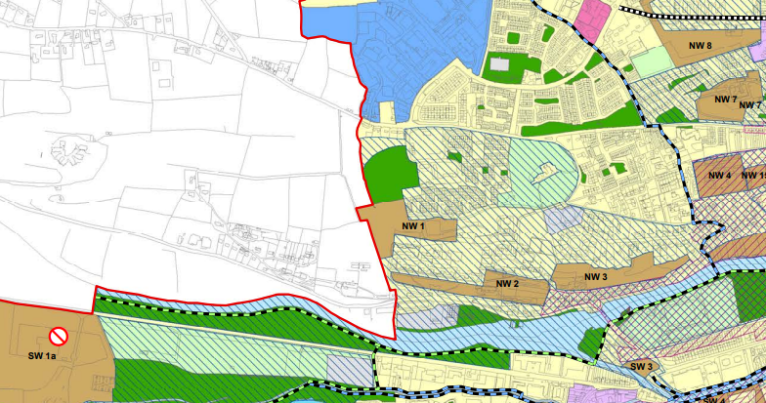
Image 1: Cork City Development Plan 2015
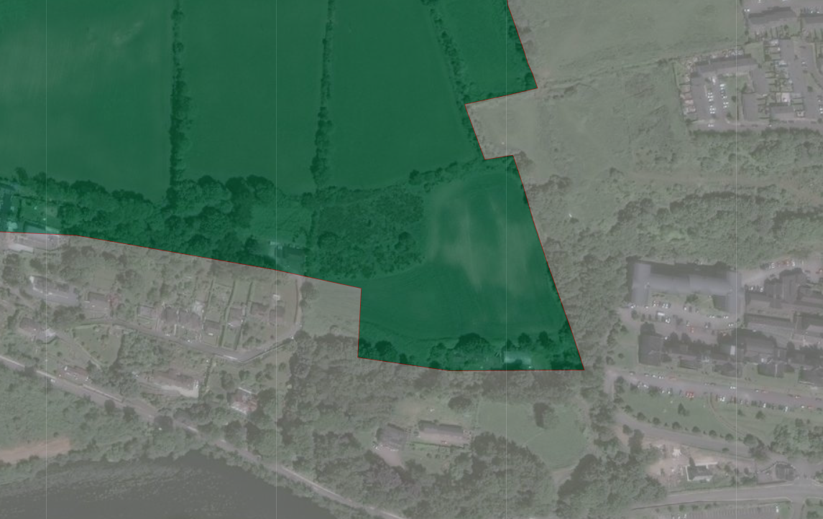
Image 2: Cork County Development Plan 2014

Prior to May 2019 this site was located within the administrative boundary of Cork County Council. The site was identified primarily as ‘Prominent and Strategic Greenbelt’. The policy for this greenbelt area at this point in time is set out as follows:

GI 8-1: Prominent and Strategic Metropolitan Greenbelt Areas requiring Special Protection
Protect those prominent open hilltops, valley sides and ridges that define the character of the Metropolitan Cork Greenbelt and those areas which form strategic, largely undeveloped gaps between the main Greenbelt settlements. These areas are labelled MGB1 in the Metropolitan Greenbelt map (Figure 13.3) and it is an objective to preserve them from development.

In May 2019 the administrative boundary of Cork City grew five times from its previous size taking in a series of larger towns and rural areas. This growth was as a result of the Local Government Act which transferred lands from Cork County Council to Cork City Council. The purpose of this boundary extension was to drive improvements in investment, public transport, infrastructure and housing. At the core of these improvements, is the policy of compact growth as set out in the NPF. This policy reflects a commitment to avoiding mistakes of the past including overdevelopment and urban sprawl.

3.0 PROPOSED AMENDMENTS 2.97 AND 2.98
I note the submission made to Cork City Council which suggests that the site is surrounded by institutional and established residential areas, following which amendments 2.97 and 2.98 have been proposed. We submit that this is a misrepresentation of the site context. This site is better defined as a rural hinterland area, with some low density housing (generally pre 60s) surrounded by greenbelt and agricultural fields on three sides.
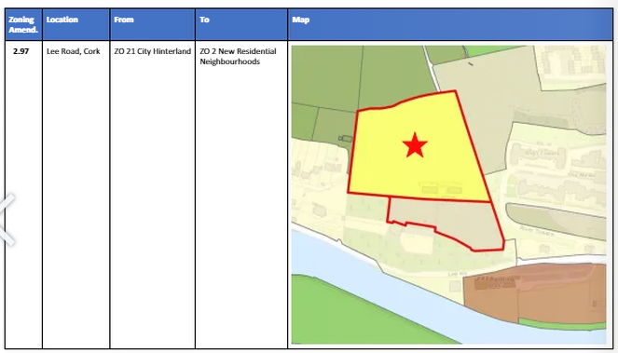
Image 3: Proposed Amendment 2.97

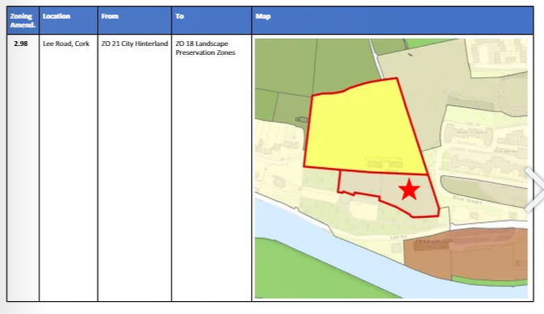
Image 4: Proposed Amendment 2.98

It is noted that the Chief Executive in her report on the Draft Development Plan dated the 20th of December 2021 recommended that no changes be made to the zoning of this site proposed as to rezone these lands would erode the hinterland which surrounds this part of the City.

We would concur with the recommendation put forward in the Chief Executive’s Report. We further note that a vote was proposed by Comhairleoir Denis Cahill and Comhairleoir Terry Shannon. Both of these Council Members represent Cork City South East. This site is located in Cork North West and will dramatically affect the residents of this area while concurrently impacting the future of Cork City as a compact settlement. It is not understood to this community as to why this proposal was made by two South East Members, but we would compel the Chief Exec and the Members of North West to seriously consider the implications of this proposal.

4.0 GREENBELT, SETTLEMENT AND ENVIRONMENTAL CONSIDERATION
The greenbelt of Cork, referred to now as hinterland in policy terms, is an urban containment tool. There is no greater tool for this City to achieve compact growth as required by the NPF than retaining, strengthening, and reinforcing the greenbelt (hinterland) of Cork City. Instead, what is being presented to the public and our community in this consultation is its erosion and destruction. This is contrary to the policies of the National Planning Framework and the Regional Spatial and Economic Strategy for the Southern Region.

National Policy Objective 62: Identify and strengthen the value of greenbelts and green spaces at a regional and city scale, to enable enhanced connectivity to wider strategic networks, prevent coalescence of settlements and to allow for the long-term strategic expansion of urban areas.

RSES Metropolitan Open Space, Recreation and Greenbelt Strategy: It is an objective to achieve a healthy, green and connected metropolitan area through the preparation of a Metropolitan Open Space, Recreation and Greenbelt Strategy. This will require co-ordination between relevant stakeholders to deliver the sustainable development of parks, recreation and high quality public open space in the Cork Metropolitan Area. This Strategy may include, inter alia:
- An enhanced network of regional scaled parks in Metropolitan Cork and invest in upgraded facilities including Tramore Valley Park, Marina Park, Bishop Lucey Park Redevelopment, Northwest Regional Park, Riverside Public Walk (Lee Field to the Marina). Lee Fields Walk/Cycle extension to Ballincollig, Lough Redevelopment, Tivoli Docks Park, neighbourhood parks and public parks in the Metropolitan Towns.
- The sustainable development of green infrastructure as an interconnected series of green spaces including parks, natural green spaces and ecosystems, greenways and blueways.
- The implementation of Greenway initiatives that provide important economic, leisure and tourism, health, active and sustainable travel and environmental benefits to the metropolitan area including the Lee to Sea Greenway initiative subject to the outcome of environmental assessments and the planning process. d. In order to support decision-making in increasing recreation and tourism opportunities along the coastline, which is in close proximity to European Sites, the carrying capacity of SACs/SPAs will need to be established to understand what limits should be set for the extent of development.
- Protect and proactively manage and integrate natural spaces.
- The sustainable development of key recreation, sports and community facilities across Metropolitan Cork. g. The development of a Metropolitan Greenbelt Strategy in co-ordination between Cork City Council and Cork County Council.

This site if adopted as per the proposed amendment will consolidate a ribbon of development with an urban area. There is no clearer definition of sprawl and coalescence than that being proposed in this amendment to the Plan. This change to the fundamental role of Cork’s greenbelt (hinterland) will alter the landscape of the city forever more, and will repeat the horrendous impacts previously experienced during the Celtic Tiger of urban sprawl.

Fragmenting the separation between the city and its hinterland as well as fragmenting the ecological value of this site, will cause irreputable damage to our City.

We note that the proposed amendments 2.97 and 2.98 have been informed by a Masterplan prepared by Reddy Architecture. The Council, in referring to this Masterplan will note that the area proposed to be zoned landscape preservation is proposed to incorporate an access roadway to the ‘new neighbourhood’, as well as landscaped areas. While at first glance this may appear to be a low impact use, this is in fact a very significant impact in terms of ecological and biodiversity impact, given that each tree which will be required to be removed are in excess of 60 years old.

Additionally, to rezone the lands to the north for residential (new neighbourhood) development would impact the routes of these herons, owls and bats. It would fragment their habitat beyond repair. Trees on this site are in excess of 60 years old, the removal of any of these is considered a ‘significant’ and ‘permanent’ impact. Landscaping this area would never provide a return on the ecological value presently here. As the Council will be aware a beak of even 4m in a bat core sustenance area can cause impacts which can never be undone. Similarly the loss of a heronry at this site will impact the Cork Harbour SPA, and the overall ecological make up of our City.

While it is recognised that greenbelts adjoining urban areas also fulfil a strategic purpose, as a potential asset for future, planned development such as an urban extension, particularly at a city scale, this is not the case here. As mentioned in 2019 Cork City expended to five times its scale. The purpose of which was to ensure that planned expansion occurred within settlements to fulfil compact growth. This is the coalescence of a rural ribbon with a City settlement.

Moreover, it is quite confusing to this community that while the above outlined amendments of 2.97 and 2.98 are being proposed, no amendments have been made in this Phase 3 process to Figure 6.5 previously identified in the Phase 2 Draft Plan. One may still feel that the site is being retained within the Prominent and Strategic Hinterlands. It is most unclear as an amendment has not been made if both policies are to coalesce?

The subject site is clearly identifiable within the Figure. However ‘New Neighbourhood’ policy is neither associated with the Hinterland or Hinterland Settlement policies. The Council I’m sure can appreciate that this causes significant confusion in this consultation process, given that the policies when read as Phase 2 with associated Amendments outlined in Phase 3 do not appear to correlate. This does not allow for effective or fair public consultation, quite on the contrary.

As noted in the NPF, greenbelts and green spaces in our cities, play an integral role as part of the fabric of our settlements, supporting biodiversity or as a natural delineation of the settlement itself, forming the interface between urban and rural areas.

This piece of land is a bastion of the Cork greenbelt. It is the specific piece of land which delineates the settlement of the City from its rural hinterland.

These lands support significant ecology, which may be considered of County Importance. The site supports a heronry, long eared owl, buzzards, bat roosts and area of core sustenance for bats. A landscape preservation zoning for this site is not of sufficient strength to protect this site of ecological and biodiversity importance.

Lighting, traffic and movement in and near the heronry and roosts as a result of the ‘New Neighbourhood’ zoning would also fragment these habitats beyond repair.

The Council will note that the importance of our biodiversity is not restricted to legally protected areas and there are a range of measures in place to protect species and habitats more broadly. In this regard, the Habitats Directive contains obligations to protect certain species wherever they occur, while the Birds Directive contains protections for all birds, and they may only be disturbed or controlled subject to licence or derogation, as appropriate.

The SEA being prepared has notably not taken account of the amendment proposed under amendment 2.98. An extract from the SEA Report prepared by CAAS on behalf of Cork City Council is included hereunder. Note the absence of 2.98 in the table of considerations.

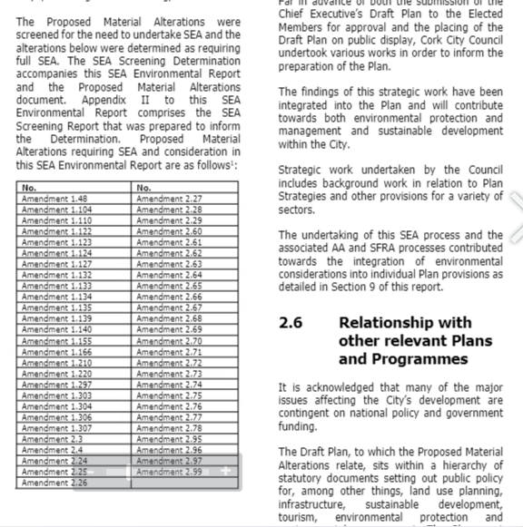
Image 5: Extracted Image from SEA by CAAS

This seems like a significant error in the preparation of the SEA Statement, given that Landscape Preservation Zoning does allow for development. An extract from the Statement is included above as published on the City Council consultation portal. While the zoning, through the development management process ‘discourages’ the removal of trees it does not ensure their ‘preservation’ contrary to what the name of the zoning may suggest. Zoning this site as Landscape Preservation Zone will undoubtably impact species identified in the Birds Directive. To not at consider this in the SEA seems like a grievous error.

The heronry on this site is associated with the Cork Harbour SPA (Site Code 004030). Although not located therein, it is a key breading ground for the SPA and the designation of same therefore extends in consideration to this site. Moreover, to have screened out amendment 2.98 from the in the Natura Impact Report, also seems like an error in the Plan making process. We compel the Council to review this screening, as it seems to have been crudely screened without any actual assessment of it’s value as a breading ground for a qualifying interest. This amendment requires a Stage 2 Appropriate Assessment. By association the zoning of the ‘New Neighbourhood’ may also require re-assessment.

Lastly, both sites 2.97 and 2.98 are of visual and landscape importance to the City. This northern ridgeline is visible from the Lee Fields, an important recreational area in the City. The removal of the visual amenity would be of significant loss to not just this community but the wider City community.

5.0 INFRASTRUCTURAL DEFECIT
This proposal would result in the zoning of land in an unserviced area with significant infrastructural deficits. The City Capacity Study prepared by Cork City Council to accompany the preparation of this Plan considered various ‘scenarios’ for proper planning and sustainable development. Two of these ‘scenarios’ entitles ‘compact liveable growth’ and ‘transport oriented growth’ notably exclude these proposed lands.

To our knowledge Irish Water have no plans to provide sewage or water upgrades to this area. These lands are unserviced greenfield lands of ecological and landscape value. They are unsuitable for this zoning and their zoning is contrary to the National Planning Framework.

The roadway at this location with a speed limit of 80km/h is not suitable for this form of development. It is unclear from the amendments made to the Draft Plan, as to which parking standards will apply in respect to a development at this site. Lee Road has not been listed amongst the new residential areas, and given that it was hinterland it would seem unusual that it would be classified as suburban with access to mass transit, as there is no nearby mass transit.

While we note the report prepared by MHL Engineers in respect to transport within the area it appears to be grossly misinformed. There are no city bus routes on the Lee Road. The nearest stop at Sundays Well would be 25/30 minutes walk from dwellings within this site. 20 minutes has been widely proven as the distance/time a person is generally willing to walk to public transport or engage in active travel. Busconnects which was launched by Cork City and County Councils this month, includes no provision for the Lee Road.

Assuming therefore it is zone 3 settlement, this provides for an allowance of 2 spaces per 1- 2 bed unit, 2 spaces per 3 bed and 0.25 visitor spaces. Within the Masterplan there are no 1-2 bed units. For 137 units this is 274 occupant spaces ₊ 35 visitor spaces (309 spaces). This does not take account of the shop or other uses on site. To zone these lands would be a traffic hazard in an area of infrastructural deficit.

The report by MHL refers to a footpath upgrade. Indeed, an upgrade has been taken at the Bon Secours in Mount Desert. This is located c. 1km west of the site i.e. it is located away from the City. It serves as a recreational footpath generally as there are no services in that direction with the exception of the Bon Secours. The new footpath is located beyond even the Lee Clinic.

The footpaths within the vicinity of this site, which have not been maintained by the City Council since the transition of lands from the County Council can scarcely fit one person, either by reason of width, foliage, telephone polls etc. When you meet someone on this footpath who is travelling in the opposite direction to you, either you or the other person has to step out onto the 80km/h roadway with concealed bends. To adopt a new neighbourhood zoning at this site, with no commitment to infrastructural upgrades is profoundly premature.

The MHL report also refers to a strong cycling network within the area. Which is honestly quite baffling. While some of us do cycle to work and/or the City, it is by no means a safe activity on the Lee Road. To introduce additional traffic, pedestrian and cycle movements on this dangerous road would cause an even greater hazard.

Lastly, we note from the submission made by McCutcheon Halley on the Draft Plan that a 20m wayleave for the Northern Distributor Road has been identified. This has been located adjacent to Hollymount Residents. The location within CMATS is far less specific and is subject to further consideration. To locate a Distributor Road close to an established residential community and further force the erosion of the greenbelt of Cork by reason of this zoning is premature.

6.0 CONCLUSION
We understand that at this stage of the plan making process, Members may only ‘accept’ or ‘reject’ the amendment. We compel the Council to reject amendments 2.97 and 2.98. Given that the site suffers from significant infrastructural deficits in terms of footpaths, roadway capacity, wastewater and water capacity. Moreover, zoning this site will pave the way for development within the long-established greenbelt of Cork, now referred to as hinterland in policy terms, which will be severed forever by reason of rezoning. This severance will impact the achievement of compact growth within Cork City and will sever beyond repair biodiversity assets of cunty wide value in the form of a heronry (associated with the SPA), bat roosts and habitats of the long-eared owl.

We would like to thank you for your consideration of this submission. Should you have any further queries please do not hesitate to contact the undersigned.

Yours Sincerely,

________________
Hollymount Residents Association, Lee Road
c/o Dr. Michael Madden

