Development Plan Submissions
Strategic and Economic Development
Cork City Council
City Hall
Anglesea Street
Cork
T12 T997
4th October 2021

RE: SUBMISSION IN RESPECT OF LANDS AT LENAGHMORE and farmers cross .

Dear Sir/Madam,

I, Kevin Duggan, wish to make this submission to the Draft Cork City Development Plan 2022-2028 in respect of lands at Lenaghmore and Farmers Cross, Cork City.

My submission requests the Planning Authority to amend proposed policies for lands at Farmers Cross and Lenaghmore as they relate to Cork Airport and explicit acknowledge the presence and importance of over 60 residential dwellings alone with my own in the immediate area through the delineation of an appropriate development boundary around the settlement.

As it stands, it would appear to me that the Draft Development Plan completely ignores these properties and places inconsistent and unwarranted restrictions on their development; restrictions that contrast sharply with the promotion of extensive new business and technology and commercial uses at other locations in close proximity to the Airport.

The extent of existing residential development in the area is evident in the map shown below.

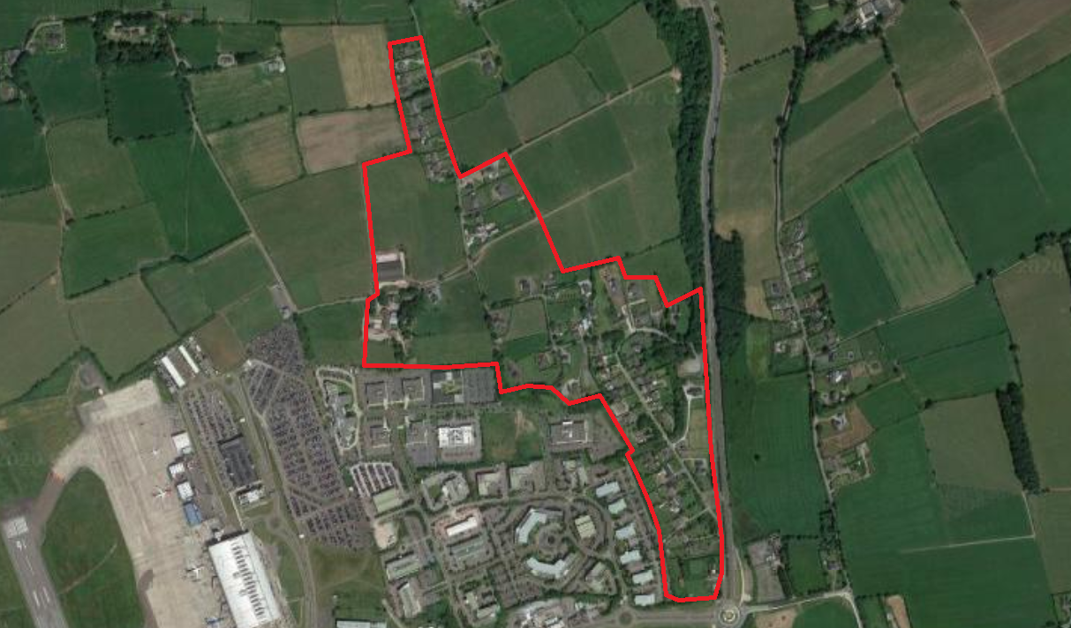
Figure 1. The Built Up Residential Area at Farmers Cross Area in Context.

The lands are also included within an area delineated as ZO 23 Airport Development Safeguard & Framework Area.

These objectives are shown below in an extract from Map 15 of the Draft Development Plan.

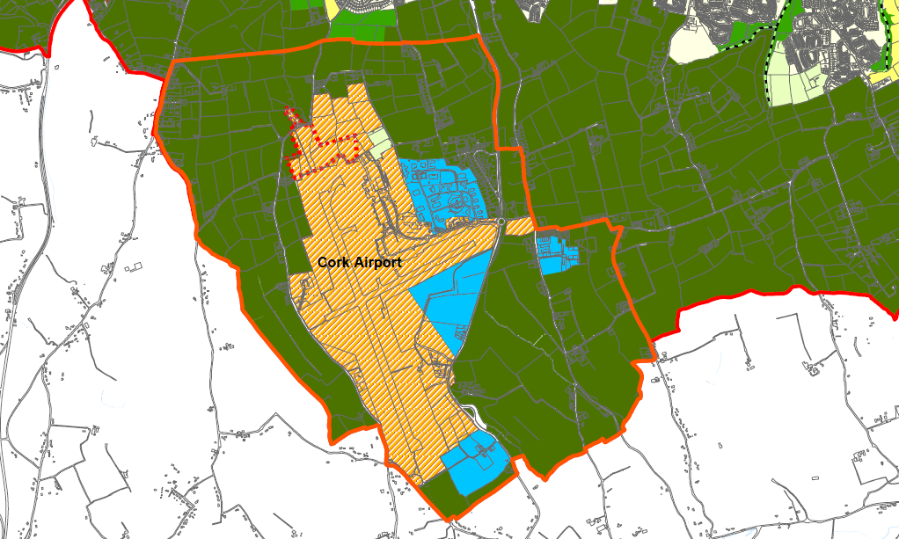
Figure 2: Proposed Draft Cork City Development Plan Zoning Objectives – Map 15

Objective 10.52 of the Draft Plan concerning the Airports Safeguard Area states:

This objective is intended to safeguard the sustainable development of the Airport. All proposed developments within this area will be referred to the Irish Aviation Authority by Cork City Council’s Development Management Section to seek their observations as part of the statutory planning process under Section 28 of the Planning and Development Regulations, 2001.

In addition, the construction of one-off housing will generally not be permitted save for exceptional circumstances such as those actively engaged in farming. Additional requirements for the construction of dwellings in this area are set out in the Cork Airport Chapter.

Section 10.182 states that

A new Framework Plan for the Airport and surrounding area will be prepared during the lifetime of this plan.

Development objectives for the area are therefore entirely focused on the protection and expansion of the Airport.

In short, it would appear that the Draft City development Plan has completely ignored that fact that there are over 50 residential properties clustered together in this area.

While identified on Map 15 of the Plan, there does not appear to be any written objective for ZO 23 which is stated to be an “Airport Development Safeguard & Framework Area”.

Nor is there any written objective in Chapter 12 for ZO 24, which is notated as “Runway Extension”.

Indeed section 12.2 of the Plan states that there are only 22 zoning objectives and not the 24 suggested by Map 15.

This, I must state, is a very significant omission from the Draft Plan.

Landowners and residents can only speculate as to this proposed zoning of their properties and the implications this may have for their value and protection.

This contrasts with all other 22 zoning objectives, which have their purpose, intention and nature clarified in Chapter 12 of the Draft Plan.

I submit that it is crucial that the preparation of this Framework Plan does not disenfranchise or marginalise property owners and residents who will be most impacted by development at the Airport.

The final Development Plan should therefore clearly acknowledge the importance of engagement with all stakeholders in the area during the preparation of this Framework Plan.

Additionally, it should be acknowledged that existing dwellings and properties in the area, and their continued use as residential homes, will be properly accounted for in the preparation of the Plan. This could take the form of a specific development objective.

While I acknowledge the importance of the Airport to the region’s economic well-being and future development, this should not be at the cost of existing residents in immediate proximity to the Airport.

It can be rectified by the establishment of a development boundary around the settlement at Framer’s Cross giving statutory recognition to its existence. In addition, any new Framework Plan for the area must include all stakeholders including residents and this should be stated in the Development Plan.

I respectfully ask that the points herein are addressed by the City Council in the new City Development Plan.

Yours sincerely,

________________________
Kevin Duggan

