Maps

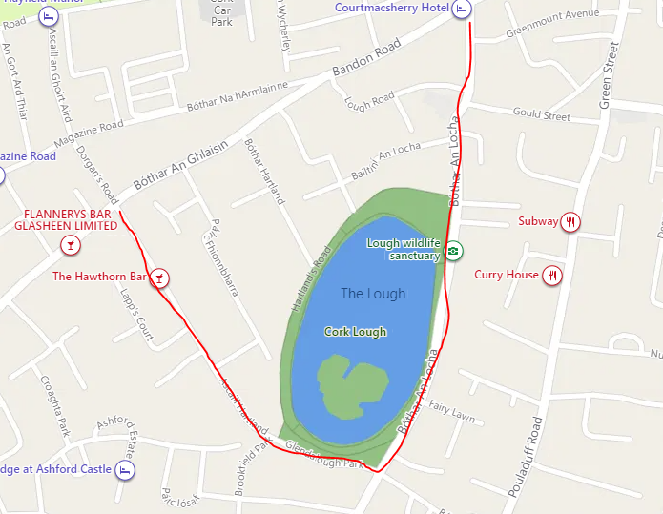

Area for one-way traffic system -see redline route

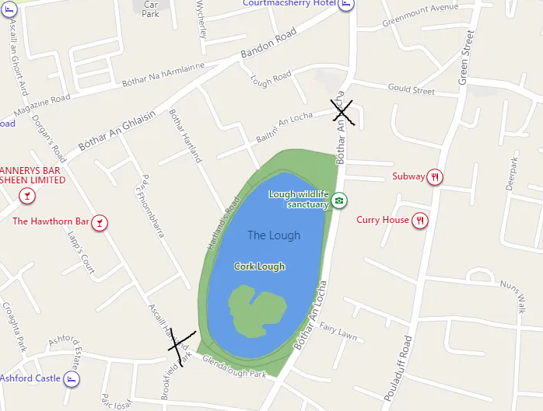

Dangerous Bends-Narrow Section of Road on Hartlands Avenue + Lough Road X

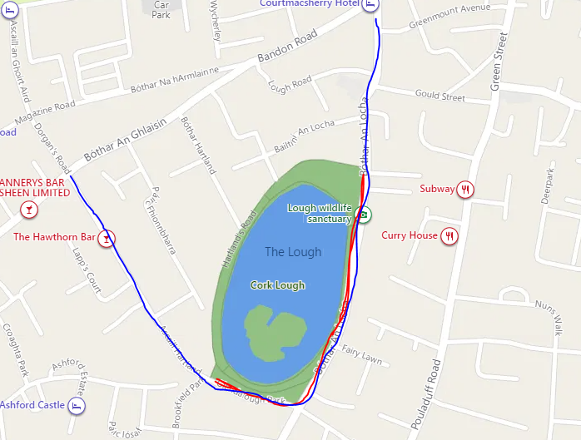

Improved Green Transport at the Lough, Lough Road + Hartlands Avenue. Opportunity to increase the size of the Lough Park to the South + East

