
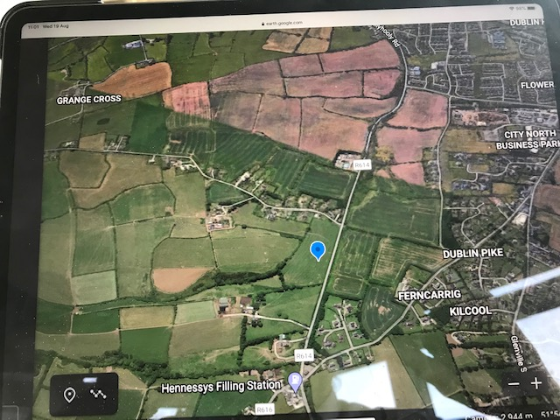

SUBMISSION TO

Cork City Development
Plan 2022-2028.

ON BEHALF OF

GARRANEBOY LTD.

Prepared by
DFOD Consultants,
Clyde House,
Brian Boru Street,
Cork.

1. INTRODUCTION

1.1 The offices of DFOD Consultants was retained by Mr. Aidan Linehan, of Property Garraneboy Ltd. to make a Submission to this 2022-2028 Plan during the Pre-Plan Consultation period.

1.2 Garraneboy Ltd. is the Company who owns circa 10.4 acres which lies on the R614 just South of Whites Cross.

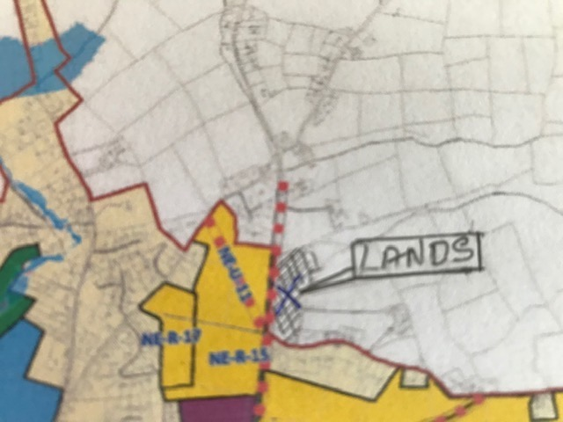
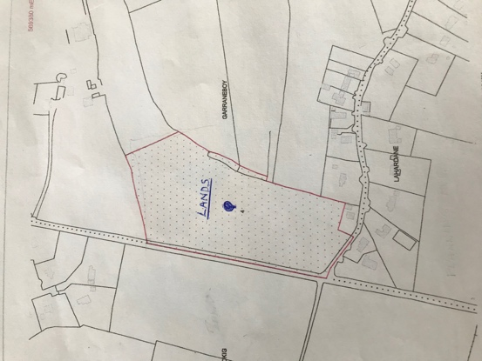

1.3 It is not the intention of the writer to copy/paste the various aims/policies as laid out in the existing Cork City Development Plan, the Cork County Council Development Plan or the Cobh Municipal District Local Area Plan as the Planners are already aware of the Aims/Policies.

2. STATUS OF SITE AND REZONED RECOMMENDATION

2.1 The proposed lands lie some 500m South of Whites Cross and at the junction of the R614 and Laherdane Road. The site slopes from east at generally 1 ml 20 slope to the R614.

2.2 These lands are contiguous to the with the Ballyvolane Urban Expansion Area and in particular the recent permitted Strategic Housing Development at Laherdane and Ballincollig which includes a Local Centre, Creche, Doctors Surgery and Community use unit and School Sites.

2.3 The foregoing permission will have to provide the necessary services to a point 300m from this proposed site, in the first two phases. Hence services will be available within 2 to 3 years from now.

2.4 The subject lands are contained within the Metropolitan Cork Strategic Land Reserve – Cork County Council. The lands will provide a suitable site for Low-Medium Density Housing which could provide for retirement homes and individual sites.

None of these categories have been provided within the adjoining development in Laherdane.

Alternatively, these lands could provide for a combination of Medium Density Housing and Individual House Sites and little cluster of retirement homes.

2.5 This type of zoning would comply with:

- National Target for the expansion of major Cities.

- National Planning Framework.

- There are no topographical challenges in this proposed site.

- The site complies with the Policies set out in the Cork County Development Plan and the Cobh Municipal District Local Area Plan.

- The forthcoming transport and water supply requirements together with the advent of Planning at Laherdane ensures more development.

2.6 This site will have all the available services within a short period of time.

Surface Water Attenuation in this area is very achievable on site to the 1 in 100 year storm which will be designed to have a further factor of safety of 25% in compliance with SUDS.

The location of an entrance to this site will have sight distances in excess of DMURS requirements.

3.0 CONCLUSION

3.1 I would respectfully suggest that this site should be zoned low/medium density Residential as it will have all the essential services in the short term.

3.2 Further, a safe entrance on to the R614 and provide entry to the lands to the east which are also included in the Strategic Land Reserve.

It could also provide individual House Sites which are necessary for persons with special needs.

3.3 I would propose that lands as outlined in Red on the attached map would be designed a Zoning as follows:

Specific Zoning Objective
“Low/Medium Density for Residential Development with provision for Retirement Homes and the possible road access to lands remaining in the Strategic Land Reserve and incorporating the retention of the natural Hedgrow boundaries.”

