Fionn Laoi Residents Association: Submission on the Draft Cork City Development Plan 2022-2028.
The residents of Fionn Laoi are of course aware that we live in close proximity to a major river. It’s a beautiful amenity and probably played a big part in our choice to live in Fionn Laoi. In making our decision, some of us researched the risk of flooding, and were relieved that the official flood risk was “Low”. However, with recent climate change reports and increasing impacts around the world, we are not surprised to learn that the Fionn Laoi flood risk rating has increased.
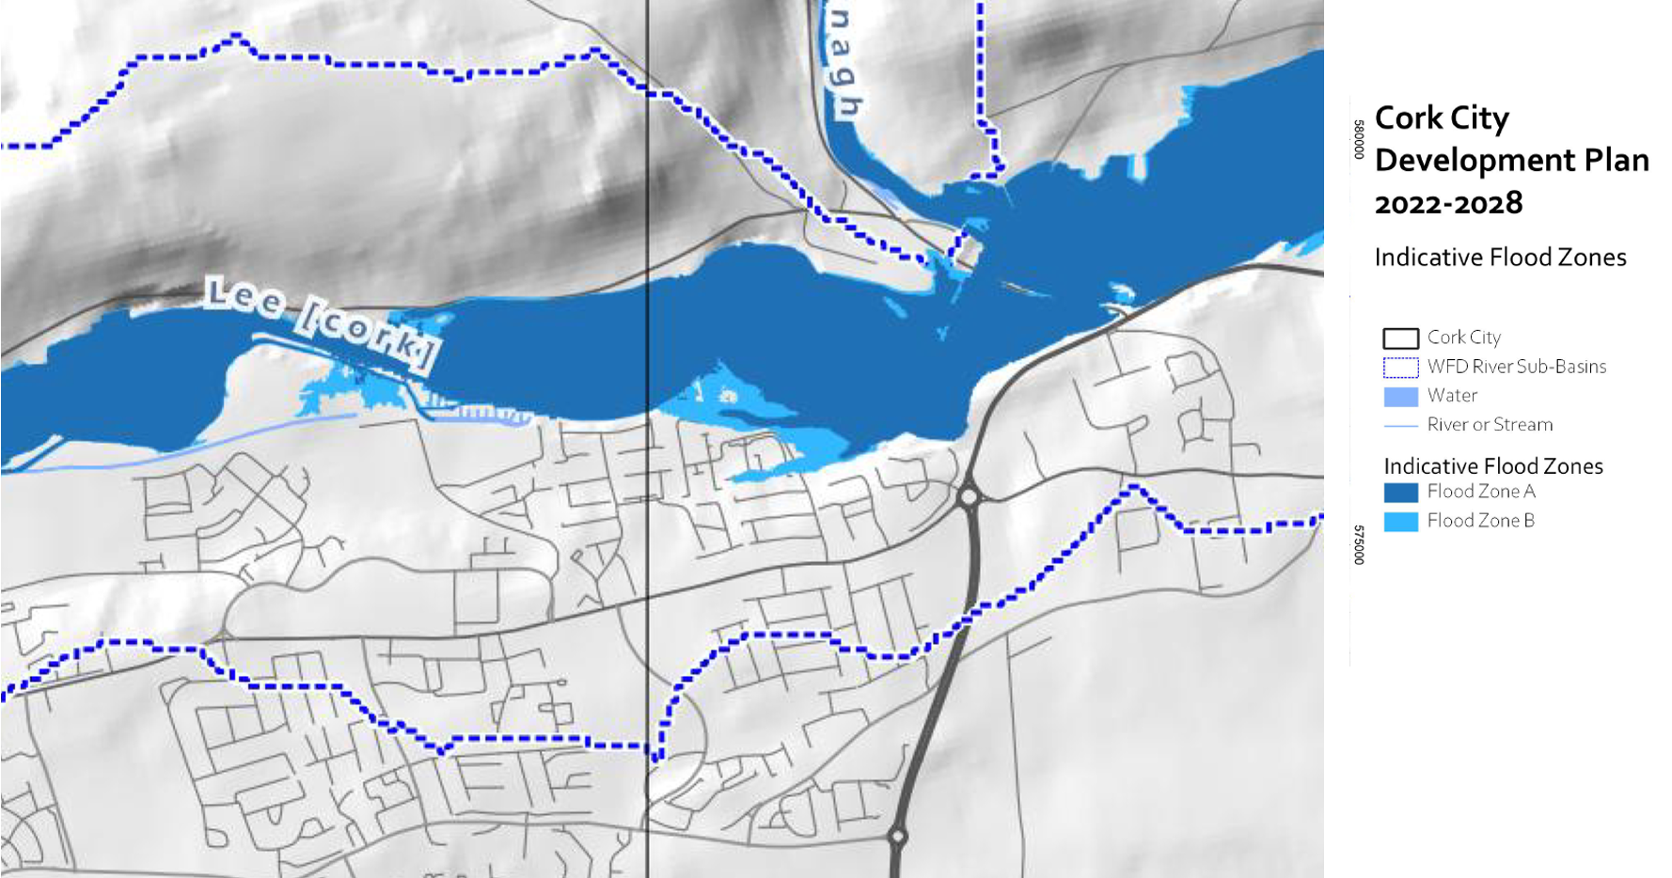
The above detail from the Indicative Flood Zones diagram shows that Fionn Laoi is marginally in Zone B. At moderate risk. We note the recommendation that
“. . a precautionary approach to climate change is adopted due to the level of uncertainty involved in the potential effects.” and
“. . that significant changes in the flood extent may result from an increase in rainfall . . “.
The current Flood Risk Assessment Report (part of the Cork City Development Plan 2022 – 2028) includes a Flood Relief Scheme for Lower Lee, Cork City which is currently in Stage II: Planning Process, and includes flood defences along the River Lee downstream of Inniscarra dam and through Cork city, changes to the operating procedures for the Carrigadrohid and Inniscarra reservoirs for the purposes of flood risk management and a flood forecasting system to help guide decision-making on dam discharges and, if necessary, the erection of temporary / demountable defences downstream and in Cork City.
The Fionn Laoi Residents Association are concerned that Fionn Laoi is part of a much larger area covering the Iniscarra Dam through the Lee Fields to the City. We feel this area is too broad, and covers areas that are subject to both coastal and river flooding, as well as areas such as the City, that have already been planned in detail, whereas it seems likely Fionn Laoi and other areas upstream are new developments that have no plans in place. We propose the Cork City Development Plan should explicitly identify areas such as Fionn Laoi that are newly identified as increased risk and to date have not been involved in planning processes.
Our comments are submitted as proposed amendments to the plan as follows:
Submission:

Reference | STRATEGIC FLOOD RISK ASSESSMENT Section 2.2  Progress a Flood Relief Scheme for Lower Lee, Cork City”
Comments | The current planned status represents the Lee Fields to the City. Recent developments in Ballincollig are clearly shown in the Flood Maps as Flood Zone B and A. It is important that these areas are explicitly called out to be entered into the SFR planning process.
Recommended Update | Progress Flood Relief Scheme for low lying dwellings in the Ballincollig area, specifically Fionn Laoi and others. Status Unplanned.

Reference | STRATEGIC FLOOD RISK ASSESSMENT Section 4.3 Integration of other provisions relating to flood risk management into the Plan  Objective 9.9 Flood Protection Schemes
Comments | To work with the Office of Public Works (OPW) in the progression and completion of Flood Risk Management Plans and flood relief schemes including the Lower Lee Flood Relief Scheme (LLFRS), schemes in Blackpool, Glanmire / Glashaboy, Douglas / Togher and other schemes that may be developed during the period of the plan.
Recommended Update | To work with the Office of Public Works (OPW) in the progression and completion of Flood Risk Management Plans and flood relief schemes including the Lower Lee Flood Relief Scheme (LLFRS) including Ballincollig, schemes in Blackpool, Glanmire / Glashaboy, Douglas / Togher and other schemes that may be developed during the period of the plan.

