

Draft Submission

Draft Cork City Development Plan 2022-2028

Lands at Poulacurry South, Glanmire, Cork

Prepared in September, 2021 on behalf of

Mairead Harty

Coakley O’Neill Town Planning Ltd.
NSC Campus, Mahon, Cork 021 2307000 info@coakleyoneill.ie  www.coakleyoneill.ie
Document Control Sheet

Client | Mairead Harty
Project Title | Lands at Poulacurry South, Glanmire, Cork
Job No. | CON21104
Document Title | Submission on the draft Cork City Development Plan 2022-2028
Number of Pages | 11

Revision | Status | Date of Issue | Authored | Checked | Signed
1 | Draft | 13th September, 2021 | AH | AON | 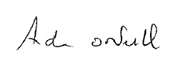

Confidentiality Statement
This report has been produced for the exclusive use of the commissioning party and unless otherwise agreed in writing by Coakley O’Neill Town Planning Ltd., no other party may copy, reproduce, distribute, make use of, or rely on the contents of the report. No liability is accepted by Coakley O’Neill Town Planning Ltd. for any use of this report, other than for the purposes for which it was originally prepared and provided. Opinions and information provided in this report are on the basis of Coakley O’Neill using due skill, care and diligence in the preparation of same and no explicit warranty is provided as to their accuracy. It should be noted and is expressly stated that no independent verification of any of the documents or information supplied to Coakley O’Neill Town Planning Ltd. has been made.

Maps reproduced under Ordnance Survey Ireland Licence Number CYAL50188676.

CONTENTS

1.0 INTRODUCTION 4
2.0 LOCATION AND DESCRIPTION 4
3.0 POLICY CONTEXT 5
4.0 PLANNING HISTORY 8
5.0 SUBMISSION 9
6.0 CONCLUSION 11

1.0 INTRODUCTION

1.1 We, Coakley O’Neill Town Planning Ltd, NSC Campus, Mahon, Cork, have been instructed by Mairead Harty, Poulacurry House, Woodbrook Road, Glanmire, Cork, to prepare this submission in respect of c.1ha of lands in her ownership to the south of Poulacurry House, Poulacurry South, Woodbrook Road, Glanmire, Cork.

1.2 This submission requests Cork City Council to rezone this redundant, vacant, underutilised area of land to the south of Poulacurry House from Public Open Space (ZO 15) to New Residential Neighbourhood (ZO 02).

2.0 LOCATION AND DESCRIPTION

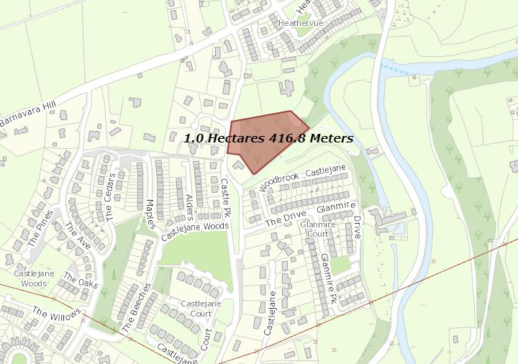
Figure 1. Site Location Map, Site Generally Indicated in Red

2.1 The site occupies a c.1 ha area of greenfield land within Glanmire, to the north-west of the village core. It is of an irregular shape, with frontage of 58m along the Woodbrook Road which connects to the Old Youghal Road (R615). There are no structures or development on the site.

2.2 The site is of varying typography typical of Glanmire. Along the west boundary with Woodbrook Road there is a 0.1 ha area that is generally level and is separated from the road by a long stone wall, rendered at the entrance to the site, and from the rest of the site by a line of mature trees. The majority of the site forms a large open field that slopes to the south. The eastern extent of the site is largely wooded and overgrown. The Butlerstown River and John O’Callaghan Park are located further east outside the site.

2.3 The immediate area consists of large one-off dwellings, including Poulacurry House (RPS: 00475 and NIAH 20860005) to the north, with some medium density suburban-type residential housing estates located to the south at Woodbrook and west at Castlejane Woods, and to the north along the Old Youghal Road (R615).

3.0 POLICY CONTEXT

3.1 The National Planning Framework (NPF) 2018, as endorsed in the Regional Spatial and Economic Strategy for the Southern Region (RSES) 2020, sets a target for Cork City of an additional 125,000 people by 2040 (to at least 315,000 people in total), an increase of almost 60% on the population recorded in Census 2016 (c. 211,000 persons).

3.2 This equates to an average additional population of 6,250 people to 2040, which represents a challenging, but, nonetheless, exciting task for the City to deliver a higher density of development, compact growth, and improved social, community and environmental infrastructure over the next 20 years.

3.3 These targets are to be delivered in an extended City boundary, which, since May, 2019, now incorporates the settlements of Blarney, Ballincollig, Togher, Douglas and Glanmire.

3.4 As the lands were previously located in Cork County Council, the provisions of the current Cork County Development Plan 2014 and the Cobh Municipal District Local Area Plan 2017 currently apply until such times as the new Cork City Development Plan 2022-2028 is adopted.

3.5 Glanmire is identified as a Metropolitan Town in the Plan, the strategic aim of which is to achieve critical population growth, service and employment centres within the Cork Gateway, as set out in policy objective CS 3-1: Network of Settlements. Policy objective CS 4-1 of the Core Strategy for the Plan states as follows:

CS 4-1: County Metropolitan Cork Strategic Planning Area
n) In the Cork Gateway development to provide the homes and jobs that are necessary to serve the planned population will be prioritised in the following locations, Carrigaline, Midleton, Carrigtwohill, Ballincollig, North Environs, Glanmire, Blarney, Monard and Cobh. Details of the proposed development will be set in Master Plan studies and Local Area Plans as appropriate.

3.6 Glanmire is identified as one of several sites for ‘Outer Suburban/ Greenfield’ development, which describes large sites on the edge of towns that may be suitable for scaled development, a density of 35-50 units per hectare will be encouraged on such sites and will include a variety of house types.
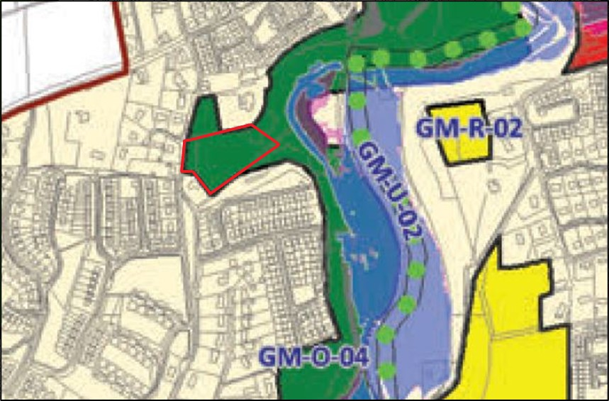Figure 2. Extract from the Cobh Municipal District Local Area Plan 2017.

3.7 As illustrated in Figure 2, the site is currently zoned as Open Space in the Cobh LAP, the objective for which in the Cork County Development Plan is to preserve and protect existing amenity space for sport and recreational uses in Glanmire. Development is not generally permitted under such zoning objectives unless there are works or structures associated with the provision of sport and recreational uses, as follows:

ZU 3-4: Appropriate Uses in Open Space, Sports, Recreation and Amenity Areas
Promote the provision of sports areas including playgrounds, sports centre’s, sports pitches, other areas or outdoor activities, outdoor recreation training centre’s, parks, landscaped areas, agricultural areas (including allotments), private landscaped gardens and woodlands in accordance with Article 10 of the Habitats Directive.

3.8 Table 11.1 of the Cork County Development Plan sets out the current capacity of water services infrastructure for all towns in the County area, in this respect Glanmire has sufficient capacity to serve the anticipated population target for both drinking water and wastewater infrastructure.

3.9 In the Cobh Municipal District Local Area Plan, 2017, Glanmire is identified as a Main Town. It is envisioned that Glanmire will play a pivotal role driving growth in the metropolitan area, as this plan also considers the importance of locating new housing within the confines of existing built up areas in Cork city and suburbs.
3.10 Glanmire is recognised within the LAP for its strategic role in facilitating future employment and population growth within the Metropolitan Area. This is set out in section 2.2.2 of the plan, which is outlined as follows:

Prioritise development to provide the homes and jobs that are necessary to serve the planned population in Carrigaline, Midleton, Carrigtwohill, Ballincollig, North Environs, Glanmire, Blarney, Monard and Cobh.

3.11 According to the LAP there were 3,535 dwellings in Glanmire, as of 2015, and it is stated that there is further capacity for an additional 1,320 units within the timeframe of the current development plan. The LAP suggests a target population of 10,585 for Glanmire up to 2023, this would result in an additional 1,205 households and a subsequent requirement for an additional 1,320 residential units.

3.12 The site is zoned as part of a large open space area within the LAP, to which the following specific policy applies:

GM-O-04 Open space for informal recreation including the provision of an amenity walk. This open space contains the Town Park, an important community amenity.

3.13 It is noted that this open space objective also applies to the private lands that form part of the curtilage of Poulacurry House.

3.14 In the draft Cork City Development Plan 2022-2028, the following is of note:
- Glanmire is identified as an Urban Town, identified as such because it has great potential to contribute to the sustainable compact growth of Cork City. Objective ZO 7 applies, which seeks to consolidate and provide for the development and enhancement of urban town centres as primary locations for mixed use retail, economic and residential growth, which also act as a focus for a range of services. Residential development will be encouraged
- The average household size in Glanmire is 3.11 (2016) which is the highest in the City
- With a policy focus on the strategic expansion for Glanmire, a population growth of 55% to 2028 is envisaged in the Core Strategy
- Table 2.5 of the draft Plan seeks to target growth proportionate to the existing population in each of the Urban Towns such as Glanmire, with a focus on prioritising walking, cycling and use of public transport, as well as the regeneration of underutilised sites
- There are no significant issues with the water and wastewater network in Glanmire
- A minimum density of 35 units per hectare is encouraged for locations such as Glanmire in the draft Plan, and
- As illustrated in Figure 3, the site retains its open space zoning objective.

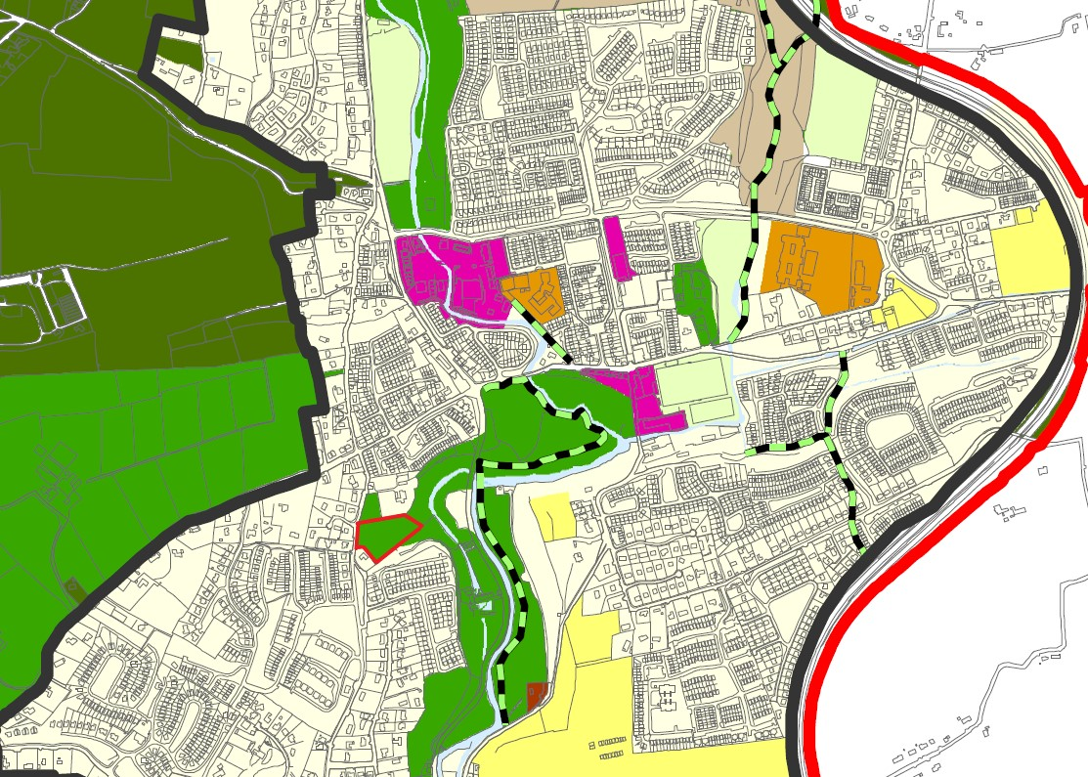 Figure 3. Extract from the draft Cork City Development Plan 2022 (site generally identified in red)

4.0 PLANNING HISTORY

4.1 There is no recent planning history associated with the site. The planning history of lands in the vicinity reflect the pattern of primarily residential development.

5.0 SUBMISSION
5.1 The site is located in the Urban Town of Glanmire, a priority location for increased population growth in Cork.

5.2 Indeed, because of its potential for sustainable development, a population growth target of 55% has been set for the town to 2028, equating to an additional 5,426 persons, is envisaged in the Core Strategy of the draft Plan. This population target is one of the highest in the City.

5.3 In the interests of achieving a compact city of scale, and to deliver on this population target, it follows that all opportunities to encourage further residential development in Glanmire should be examined.

5.4 This is particularly the case for existing, underutilised lands, such as the site at Poulacurry South, within the development boundary of Glanmire.

5.5 In this context, the site is an appropriate development opportunity that can be brought forward to Tier 1 residential use in the short-term. The advantages of the site are as follows:

- By reason of its existing extensive road frontage, access from the adjacent public road can be facilitated without traffic hazard
- With the existing network of footpaths and having regard to the proposed investment in the Glanmire Roads Improvement Scheme and the future BusConnects project, the site benefits from good connectivity with the surrounding area
- The site is vacant and underutilised
- The site does not form part of the curtilage of Poulacurry House, being at a sufficient remove and separated by the landscaped gardens and boundary hedging
- As a relatively open site, relatively flat for the most part, it does not appear to of natural heritage value
- In addition, existing services are available in principle.

5.6 Having regard to these advantageous characteristics, the existing and proposed open space zoning neither aligns nor accords with the site’s development potential and represents a missed opportunity to secure compact growth and the regeneration of an underutilised site in Glanmire.

5.7 Of importance is that the site is not used as public open space, nor has it ever been. It is private land that can be made available for development in line with the aspirations of the draft Plan.

5.8 Given:
- the principal residential land use of Poulacurry House to the immediate north
- the fact that these private lands do not form part of John O’Callaghan Park, nor are they part of the Butlerstown riverside walkway
- the established pattern of residential development in the vicinity
- the availability of services and social and community infrastructure, and
- the strategic policy provisions for Glanmire as one of Cork’s Urban Towns with a significant population target,

it is appropriate for Cork City Council to consider the role of these lands in contributing to the challenging population and housing targets set for Cork, and to rezone them from Public Open Space, which they are not, to Tier 1 New Residential Neighbourhood, to be brought forward for a residential development of c. 35 units/ha in the short-term.

6.0 CONCLUSION

6.1 In conclusion, this submission requests Cork City Council to rezone this redundant, vacant, underutilised area of land to the south of Poulacurry House from Public Open Space (ZO 15) to New Residential Neighbourhood (ZO 02), in the context of:

- The strategic function of Glanmire as an Urban Town
- The established primarily residential area of the site, and the pattern of development in the vicinity
- The nature and extent of the site as private lands to the south of Poulacurry House and attendant grounds to the north, which does not function as public open space and will never function as such, and
- The contribution the site can make to the achievement of the following planning outcomes:
  - compact growth,
  - increased population and density,
  - regeneration of underutilised land, and
  - sustain existing services and support the case for further investment in Glanmire

6.2 Please refer all correspondence to Aiden O’Neill, Coakley O’Neill Town Planning Ltd, NSC Campus, Mahon, Cork.

