Development Plan Submissions
Strategic and Economic Development
Cork City Council
City Hall
Anglesea Street
Cork
T12 T997
4th October 2021

RE: SUBMISSION IN RESPECT OF LANDS AT LENAGHMORE and farmers cross .

Dear Sir/Madam,

I, Gearóid McCarthy, wish to make this submission to the Draft Cork City Development Plan 2022-2028 in respect of lands at Lenaghmore and Farmers Cross, Cork City.

My submission requests the Planning Authority to amend proposed policies for lands at Farmers Cross and Lenaghmore as they relate to Cork Airport and explicit acknowledge the presence and importance of over 60 residential dwellings in the immediate area through the delineation of an appropriate development boundary around the settlement.

As it stands, it would appear to me that the Draft Development Plan completely ignores these properties and places inconsistent and unwarranted restrictions on their development; restrictions that contrast sharply with the promotion of extensive new business and technology and commercial uses at other locations in close proximity to the Airport.

There is, in my view, no rationale or justification for such an inconsistency.

For context, Farmers Cross comprises an area of townlands located 5km south of Cork City Centre, immediately north of Cork Airport and is situated 3.5km south west of the suburb of Douglas. The lands contain a single principal road which runs east to west connecting the settlement with the wider Cork area.

In general, development to date has largely occurred in the form of residential development forming clusters of single dwellings. The emerging pattern has become increasingly urban in form through these pockets of development, although the density remains low.

The extent of existing residential development in the area is evident in the map shown below.

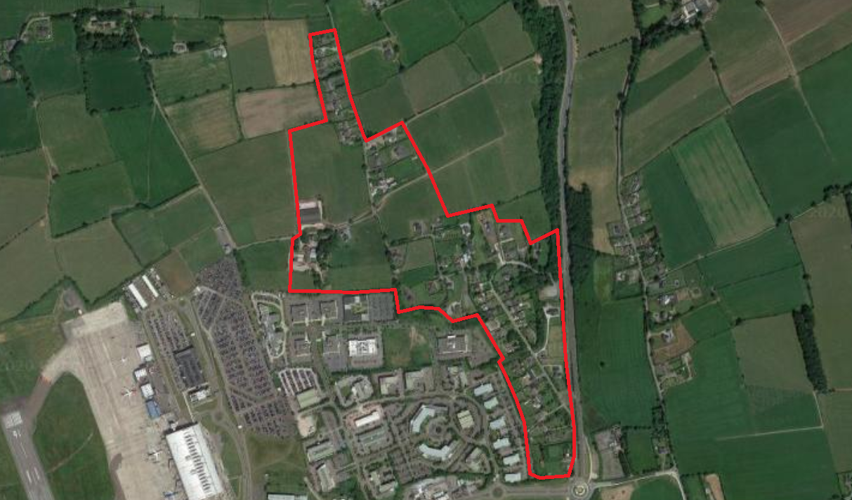
Figure 1. The Built Up Residential Area at Farmers Cross Area in Context.

The area was formerly located within the jurisdiction of Cork County Council and is currently regulated by the Cork County Development Plan, 2014–2020 (CCDP) and the Ballincollig-Carrigaline Municipal District Local Area Plan, 2017 (LAP).

Farmers Cross is located within the ‘Cork City Gateway’ and the ‘Metropolitan Cork Planning Area’. However, it is not formally recognised as part of the settlement hierarchy and falls under the lowest tier designation of ‘other locations’. The LAP includes the following specific policies for Farmers Cross;

DB-01 Recognise the current Metropolitan Green belt designation surrounding Farmer’s Cross and apply the relevant County Development Plan Objectives when assessing development proposals.

DB-02 Have regard to Public Safety Zones identified by the Airport Authority when considering any planning proposals for the Farmer’s cross Area.

Having regard to their built up nature, along an identified priority bus service and proximity to the city, there is merit in considering the designation of a proper development boundary around lands in Farmers Cross, so that their future development can be properly regulated

The purpose of such a designation would be to facilitate sustainable development, protect against the continuation of undesirable low density development in the open countryside and instead concentrate development within an existing built up area in accordance with compact growth strategies. In addition, the area has numerous sustainable development attributes that would aid the Planning Authority to achieve its vision for coordinated compact growth in the city;

- The provision of a development boundary will contribute to the identified housing need targets set out in the Issues Paper and counteract continuous low density development in the area.
- The lands are located along a priority public transport corridor as proposed in the CMATS.
- Cork Airport and the Airport Industrial Park are a major employment centre on the southside of the city, therefore the delivery of residential development near employment centres will help to reduce sustainable commuting patterns.
- The lands designated with a development boundary will encourage the consolidation of existing uses and present an opportunity to consolidate the existing built up area.

From a strategic perspective and considering the impact the revised city boundary has on the structure of the city, existing built up areas with access to public transport will play an essential role as growth centres.

Therefore, in this context Farmers Cross would benefit from a specific development boundary to coordinate its sustainable growth into the future.

In recent years development in the area has occurred in the form of single dwellings, by way of ribbon development. the designation of a new development boundary would help regulate and co-ordinate new development in the area by identifying new development opportunities to act as a counter-balance to the continuation of low density sprawl in Farmers Cross.

Under the new Draft City Development Plan however, the area is to be zoned as City Hinterland, where the proposed policy is as follows:

Zoning Objective 21: To protect and improve rural amenity and provide for the development of agriculture.

ZO 21.1The primary objective of this zone is to preserve the character of the City Hinterland generally for use as agriculture, rural amenity, open space, recreational uses, green and blue infrastructure and to protect and enhance biodiversity. Rural-related business activities which have a demonstrated need for a rural location are also permissible. Any development associated with such uses should not compromise the specific function and character of the City Hinterland in the particular area.

ZO 21.2Other uses open for consideration in this zone include renewable energy development (wind turbines, solar farms), tourism uses and facilities, garden centres and nurseries, cemeteries and community and cultural uses, market gardening and food production ancillary to agricultural uses.

The lands are also included within an area delineated as ZO 23 Airport Development Safeguard & Framework Area.

These objectives are shown below in an extract from Map 15 of the Draft Development Plan.

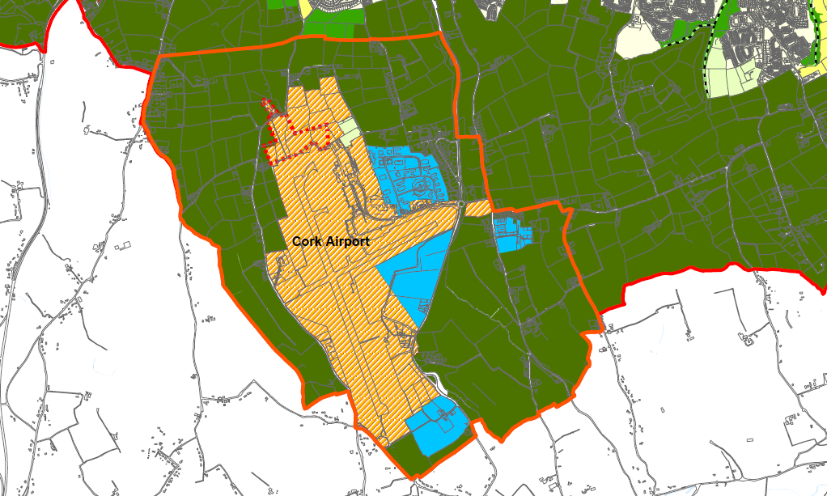
Figure 2: Proposed Draft Cork City Development Plan Zoning Objectives – Map 15

Objective 10.52 of the Draft Plan concerning the Airports Safeguard Area states:

This objective is intended to safeguard the sustainable development of the Airport. All proposed developments within this area will be referred to the Irish Aviation Authority by Cork City Council’s Development Management Section to seek their observations as part of the statutory planning process under Section 28 of the Planning and Development Regulations, 2001.

In addition, the construction of one-off housing will generally not be permitted save for exceptional circumstances such as those actively engaged in farming. Additional requirements for the construction of dwellings in this area are set out in the Cork Airport Chapter.

Objective 10.53 of the Draft Plan concerning Airport Safety Zones:

Implement the policies to be determined by Government in relation to Public Safety Zones for Cork Airport. Additionally, the Obstacle Limitation Surfaces will be safeguarded. Planning applications in the vicinity of these zones will be referred to the Irish Aviation Authority for observations as part of the statutory planning process. Issues such a proposed development’s height and proximity to these zones will form part of considerations

Section 10.194 of the Draft Plan states that:

To safeguard the future operations of the Airport new housing will not be permitted within the area delineated as Airport Safeguard Area, save in exceptional circumstances where consideration may be given to the development of new housing for those actively involved in farming

Section 10.195 further states that:

Site selection must ensure that the rural character of the area is maintained, multiple sites on single landholdings will not be permitted. Planning applications within this area shall be accompanied by a noise assessment report produced by a specialist in noise measurement which shall detail all proposed noise mitigation measures together with a declaration of acceptance of the applicant of the result of a noise acceptance report. Further indemnification Cork City Council and Cork Airport from any loss of amenity which may arise as a result of Airport Operations shall be agreed at Development Management Stage.

Section 10.182 states that

A new Framework Plan for the Airport and surrounding area will be prepared during the lifetime of this plan.

Development objectives for the area are therefore entirely focused on the protection and expansion of the Airport.

In short, it would appear that the Draft City development Plan has completely ignored that fact that there are over 50 residential properties clustered together in this area.

While identified on Map 15 of the Plan, there does not appear to be any written objective for ZO 23 which is stated to be an “Airport Development Safeguard & Framework Area”.

Nor is there any written objective in Chapter 12 for ZO 24, which is notated as “Runway Extension”.

Indeed section 12.2 of the Plan states that there are only 22 zoning objectives and not the 24 suggested by Map 15.

This, I must state, is a very significant omission from the Draft Plan.

Landowners and residents can only speculate as to this proposed zoning of their properties and the implications this may have for their value and protection.

This contrasts with all other 22 zoning objectives, which have their purpose, intention and nature clarified in Chapter 12 of the Draft Plan.

It suggests that the objectives were added at the last minute.

Notwithstanding, one can assume that the area delineated in orange on map 15 is that which will be subject to a Framework Plan for the Airport, as detailed in section 10.182.

I submit that it is crucial that the preparation of this Framework Plan does not disenfranchise or marginalise property owners and residents who will be most impacted by development at the Airport.

The final Development Plan should therefore clearly acknowledge the importance of engagement with all stakeholders in the area during the preparation of this Framework Plan.

Additionally, it should be acknowledged that existing dwellings and properties in the area, and their continued use as residential homes, will be properly accounted for in the preparation of the Plan. This could take the form of a specific development objective.

While I acknowledge the importance of the Airport to the region’s economic well-being and future development, this should not be at the cost of existing residents in immediate proximity to the Airport.

This appears to me to be a significant disconnect in the Draft Plan which one the one hand zones a series of new areas for Business and Technology development in close proximity to the Airport while on the hand, ignores long standing established residential properties in the same area.

The inconsistency here is glaring. New Business and Technology Parks are promoted, while a new residential dwelling will only be permitted in very exceptional circumstances.

Sections 10.175 through 10.181 justifies all this concluding:

In this context, it is appropriate that land use planning supports further diversification of activities at the Airport including, zoning of additional lands for Airport related enterprise activities.

Nowhere is ‘Airport Related Enterprise’ clarified or defined. So, there is no clarity there as to what restrictions will be put in place. The strong likelihood is that the Airport Business Park will continue to develop as it has always done, as a Business Park no different from any other across the city.

In addition to the new Business and Technology Parks, the list of new commercial development permitted on Airport lands is extensive.

- expansion of landside concession facilities;
- refurbishment and re-use of former terminal for Airport related commercial uses;
- expansion of Airport Hotel; expansion of long-term parking facilities
- petrol filling station

The Draft Plan even goes on to state:

This list is not intended to be exhaustive, and the other developments not listed will be considered.

A stone’s throw away at Farmers Cross, an established residential area comprising over 50 dwellings, development will only be permitted in very exceptional circumstances.

It is my view that the inconsistency presented in the Draft Plan cannot be sustained or justified in any way.

It can be rectified by the establishment of a development boundary around the settlement at Framer’s Cross giving statutory recognition to its existence. In addition, any new Framework Plan for the area must include all stakeholders including residents and this should be stated in the Development Plan.

I respectfully ask that the points herein are addressed by the City Council in the new City Development Plan.

Yours sincerely,

________________________
Gearoid McCarthy

